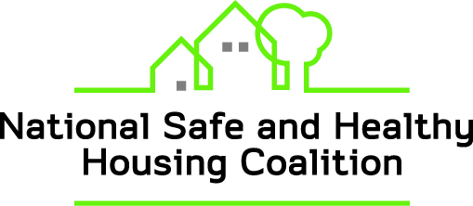

NATIONAL SAFE AND HEALTHY HOUSING COALITION Quarterly Webinar:
TUESDAY, JUNE 7, 2016 1:00 – 2:00 PM EDT
Please register at:
https://attendee.gotowebinar.com/register/3980251158618224642
HEALTHY HOUSING FOR OLDER ADULTS: Housing As A Platform For Community Health Systems
A panel of experts will speak about two successful Housing Based Services Models (HBSMs), one in Vermont and one in Oregon, and their importance in addressing the social determinants of health, promoting population health and advancing health care systems change. According to a rigorous independent evaluation of Vermont’s SASH model by RTI and LeadingAge, the Vermont model is reducing the rate of growth in Medicare spending significantly while improving health and access to care. In Oregon, the Housing with Services model brought together a partnership of housing development organizations, the state’s largest Medicaid insurance provider and several nonprofit social service agencies. A study completed by Enterprise Community Partners and the Center for Outcomes Research and Education (CORE) reports on Medicaid savings. Please join us!
Panelists include:
Nancy Rockett Eldridge, Executive Director, National Center for Healthy Housing, Columbia MD
Ms. Eldridge is the founder of the Support And Services at Home (SASH) model that has been brought to scale at 138 affordable housing communities serving seniors and persons with disabilities across Vermont as part of the state’s advanced primary care medical home system and in collaboration with hospitals, Area Agencies on Aging, home health and mental health providers.
Abigail M. Crocker, Ph.D., Research Assistant Professor, University of Vermont Department of Mathematics and Statistics
Ms. Crocker is a consultant to Cathedral Square Corporation providing statistical analysis on SASH’s impact on reducing costs, increasing access to care and improving health. Abby uses data to better understand the scope of public health concerns to inform program and policy development.
Howard Klink, Project Director, Housing with Services LLC, Klink Consulting Group, Portland, Oregon
Mr. Klink designed and implemented Housing with Services, in partnership with Cedar Sinai Park, CareOregon, Oregon's largest Medicaid insurance provider, housing development organizations and several nonprofit social service agencies. The model is operating in 11 affordable housing communities serving 1400 seniors and people with disabilities located in Portland, Oregon. The project is operated under the authority of a Limited Liability Corporation (LLC) and governed by an Inter-agency Agreement codifying the roles and responsibilities of the partner organizations committed to supporting aging in place by for seniors representing a diverse set of cultures. Howard provides project development and technical assistance support to health and housing integration partnerships locally and nationally and serves on the Oregon State Legislature’s Task Force on Housing with Services.
Amanda Saul, Pacific Northwest Senior Program Director, Enterprise Community Partners, Portland Oregon
Ms. Saul helped to design the study, “Health in Housing: Exploring the Intersection Between Housing and Health Care.” She has led the Oregon Health and Housing Learning Collaborative for the past 2 years. Amanda leads Enterprise’s programmatic work in Oregon by advancing initiatives that improve the livability of low-income residents.

Also, following the panel: Updates from the Code Enforcement and Policy Working Groups, on: code policy; federal appropriations for lead poisoning prevention, lead hazard control, and healthy homes; and pending federal legislation.
For more information contact jkruse@nchh.org

